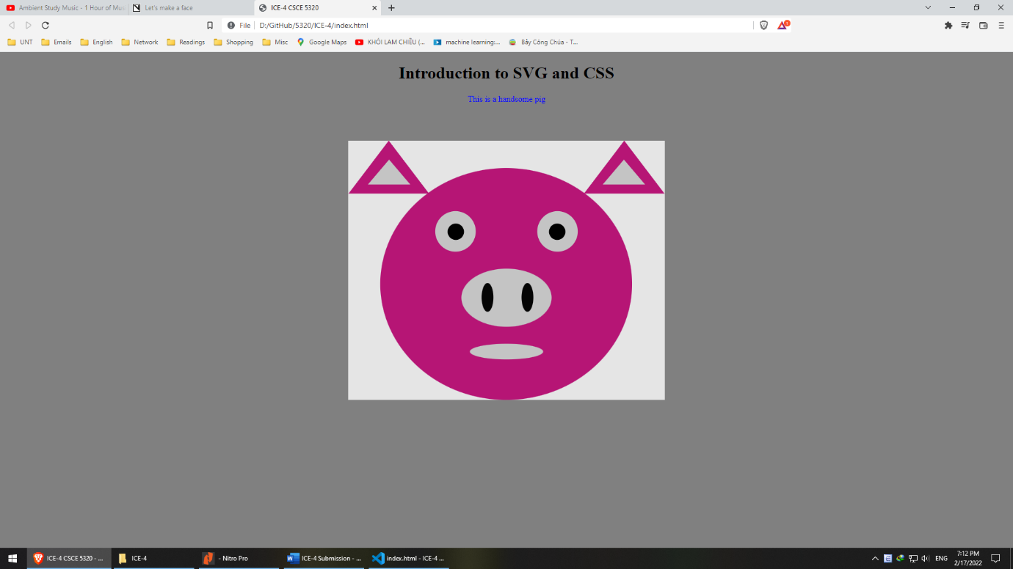

**Task 1: My webpage**

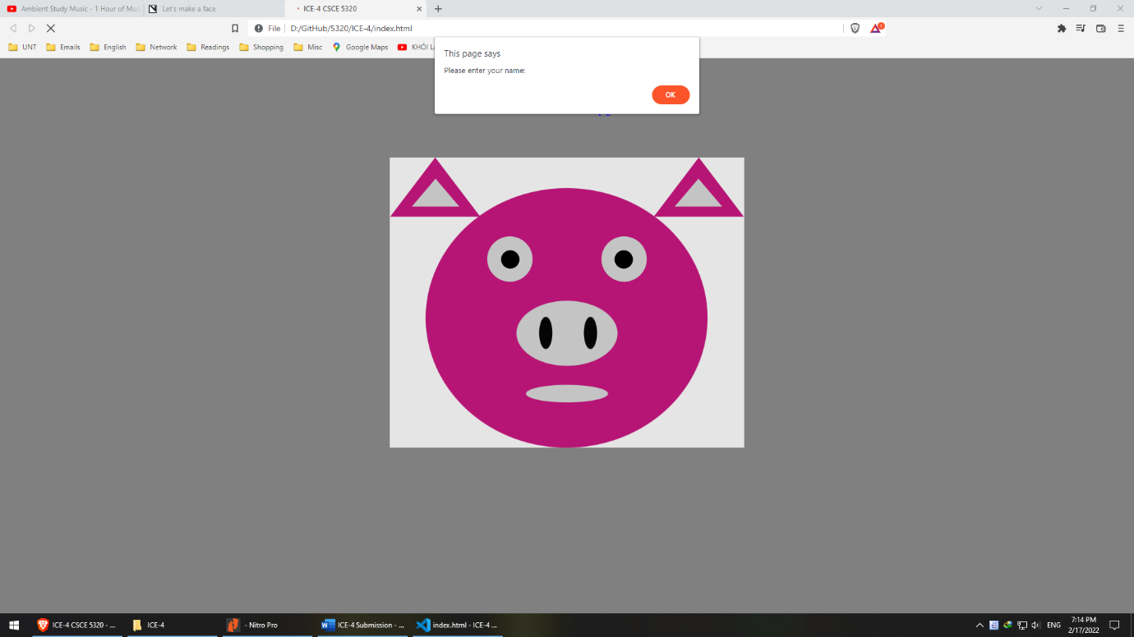

**Task 2**: My webpage with the alert

**Task 3: Vizhub link**

https://vizhub.com/teohangxanh/39023af9300245d3a7908608a5edd6c1?edit=files&file=index.js